**PROGRES PROJECT UAS**



Mata Kuliah :

|  |
| --- |
| Pemrograman Web 2 |

Oleh :

|  |  |
| --- | --- |
| 240103240 | Muhammad Adzkia Adi Syahputra |

Kelas :

|  |
| --- |
| TI24B1 |

Dosen :

|  |
| --- |
| Triyono, S.Kom |

**PROGRAM S-I TEKNIK INFORMATIKA**

**FAKULTAS ILMU KOMPUTER UNIVERSITAS DUTA BANGSA**

**SURAKARTA**

**TAHUN AJARAN 2025/2026**

1. Link Github

<https://github.com/skill-tzy/kiapotik_laravel>

2. API Laravel  
a. Check Endpoint

Method: GET

URL: http://127.0.0.1:8000/api/health

Kegunaan: mengetes apakah server atau API kamu sedang hidup (aktif) dan bisa merespons dengan benar.

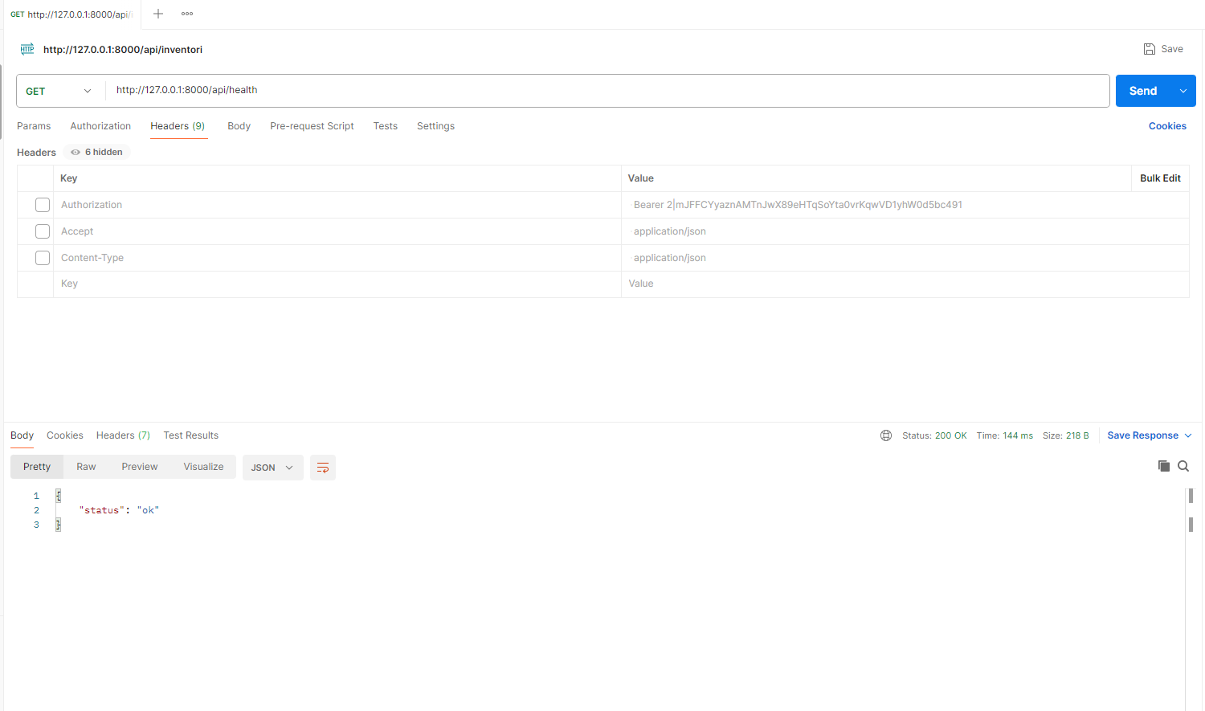

b. Buat Akun Baru

Method: POST

URL: http://127.0.0.1:8000/api/auth/register

Headers:

Accept: application/json

Content-Type: application/json

Body -> raw

{

"name": "Adzkia",

"email": "adzkia@gmail.com",

"password": "password",

"password_confirmation": "password"

}

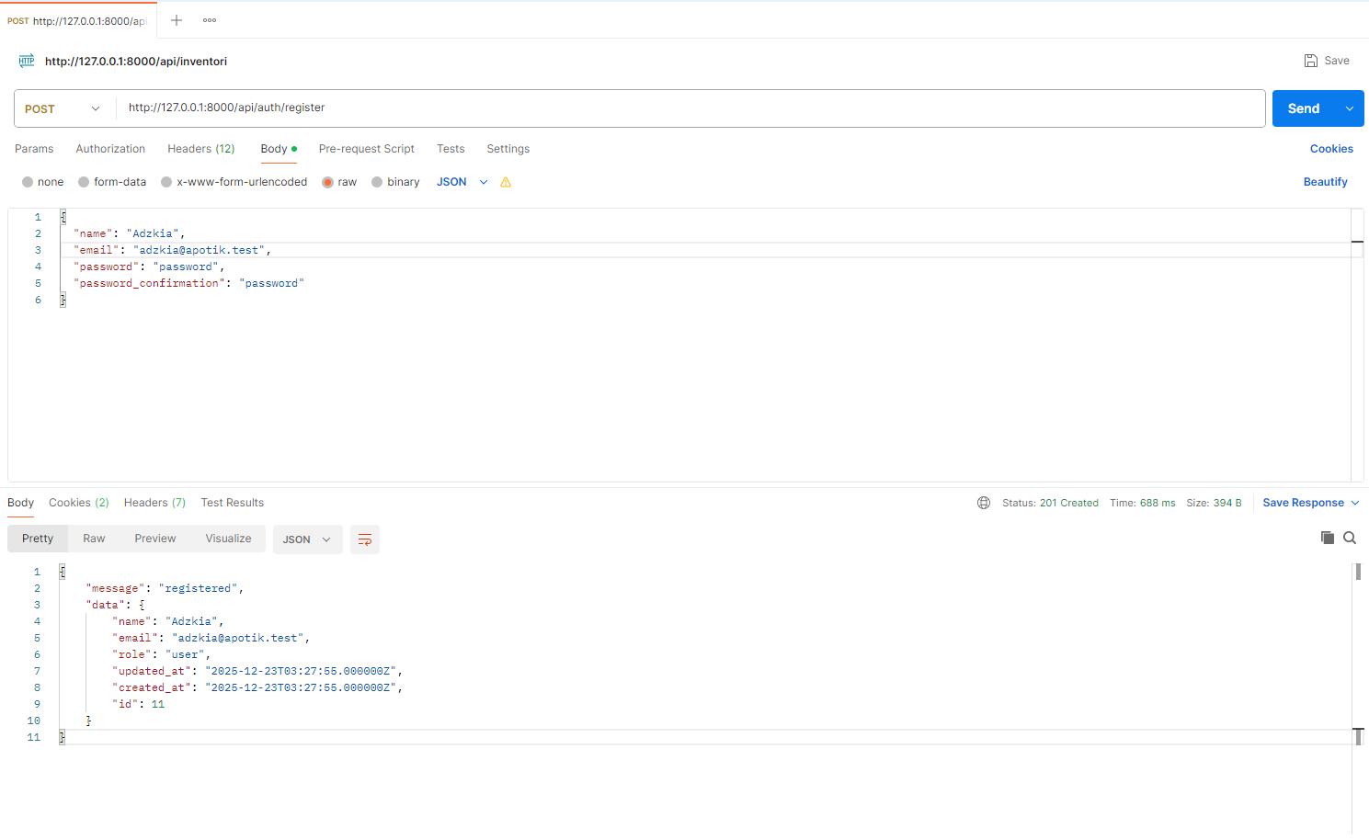

c. Login - Ambil Token

Method: POST

URL: http://127.0.0.1:8000/api/auth/login

Body -> raw

{"email":"demo@example.test","password":"password"}

*Ambil Token

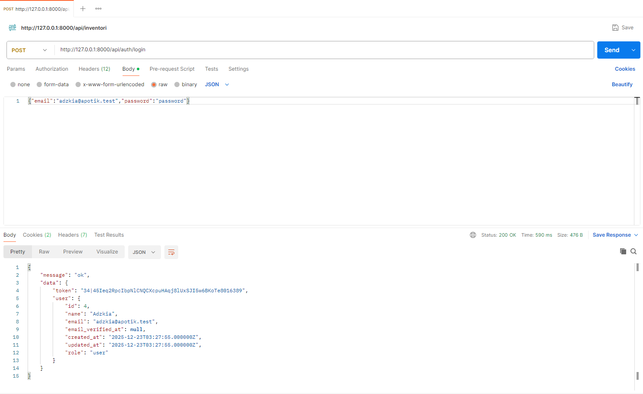

d. Me (cek siapa yang login)

Method: GET

URL: http://127.0.0.1:8000/api/auth/me

Headers:

Authorization: Bearer <token>

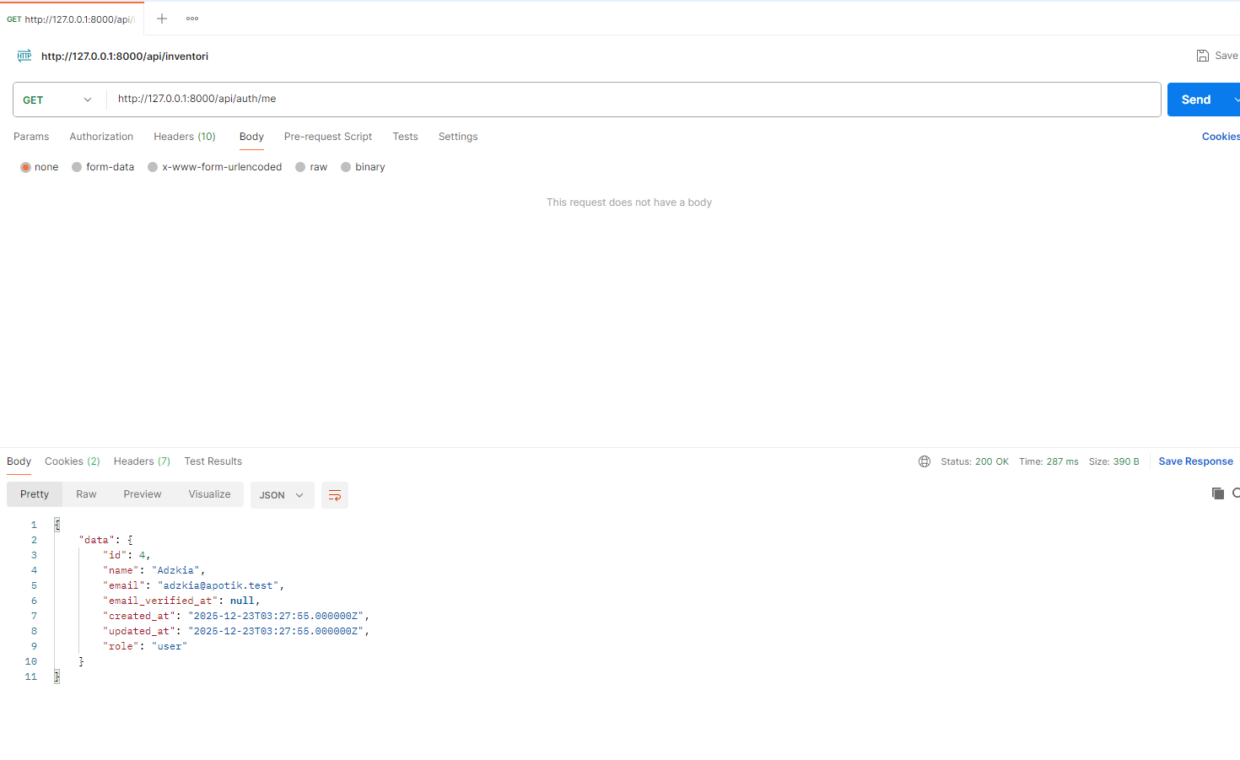

e. Lihat Semua Produk

Method: GET

URL: http://127.0.0.1:8000/api/inventori

Headers:

Authorization: Bearer <token>

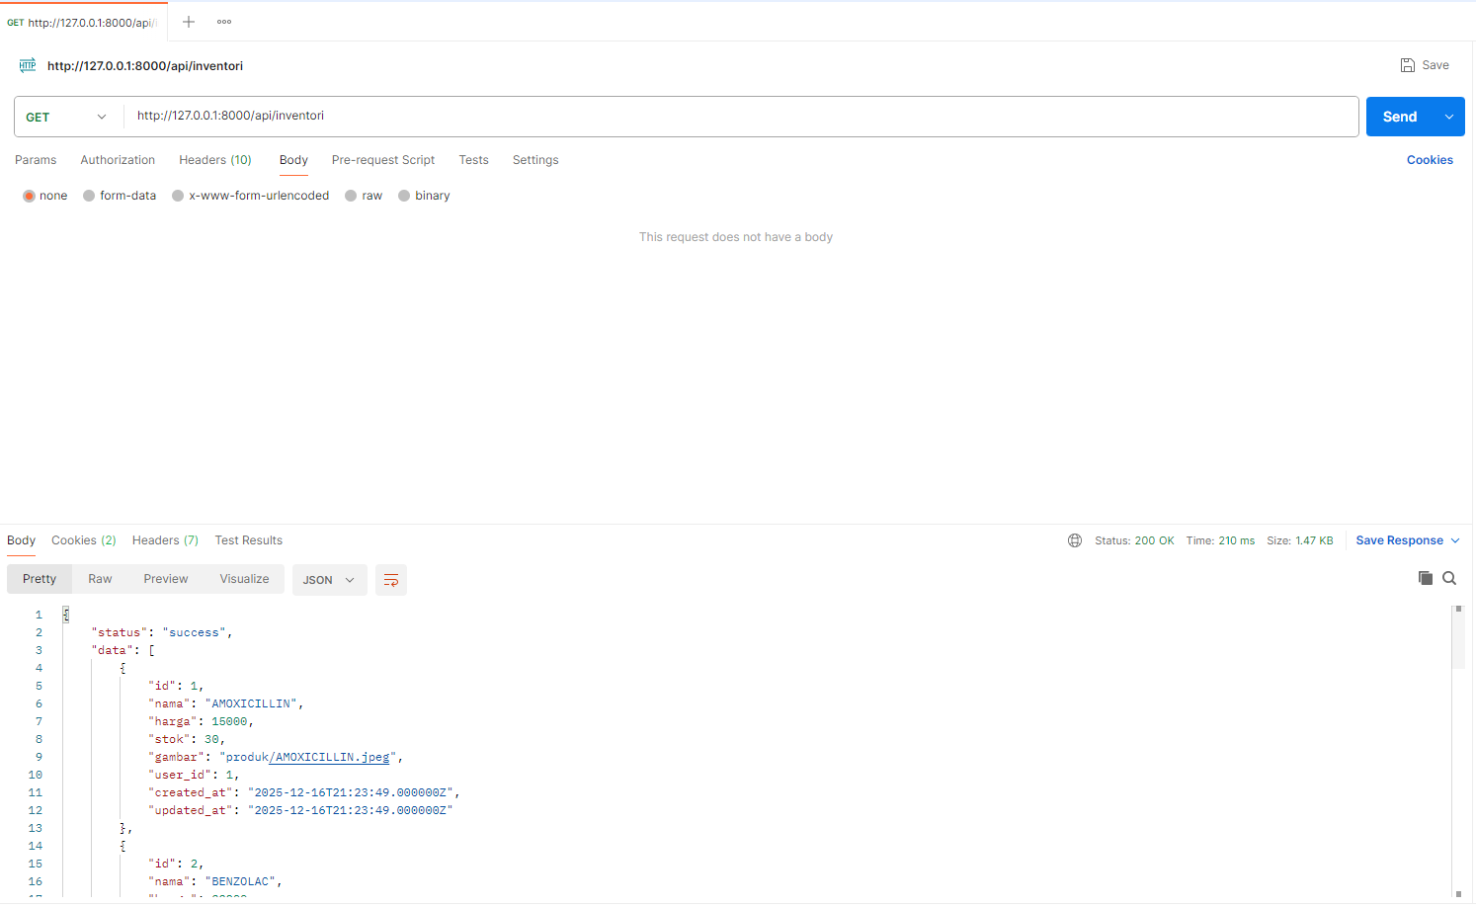

f. Tambah Produk

Method: POST

URL: http://127.0.0.1:8000/api/inventori

Headers:

Accept: application/json

Authorization: Bearer <token>

Body -> form-data

|  |  |  |
| --- | --- | --- |
| Key | Value (contoh) | Type |
| nama | ANTANGIN 500mg | text |
| harga | 12000 | text |
| stok | 50 | text |
| gambar | (pilih file jpg/png) | file |

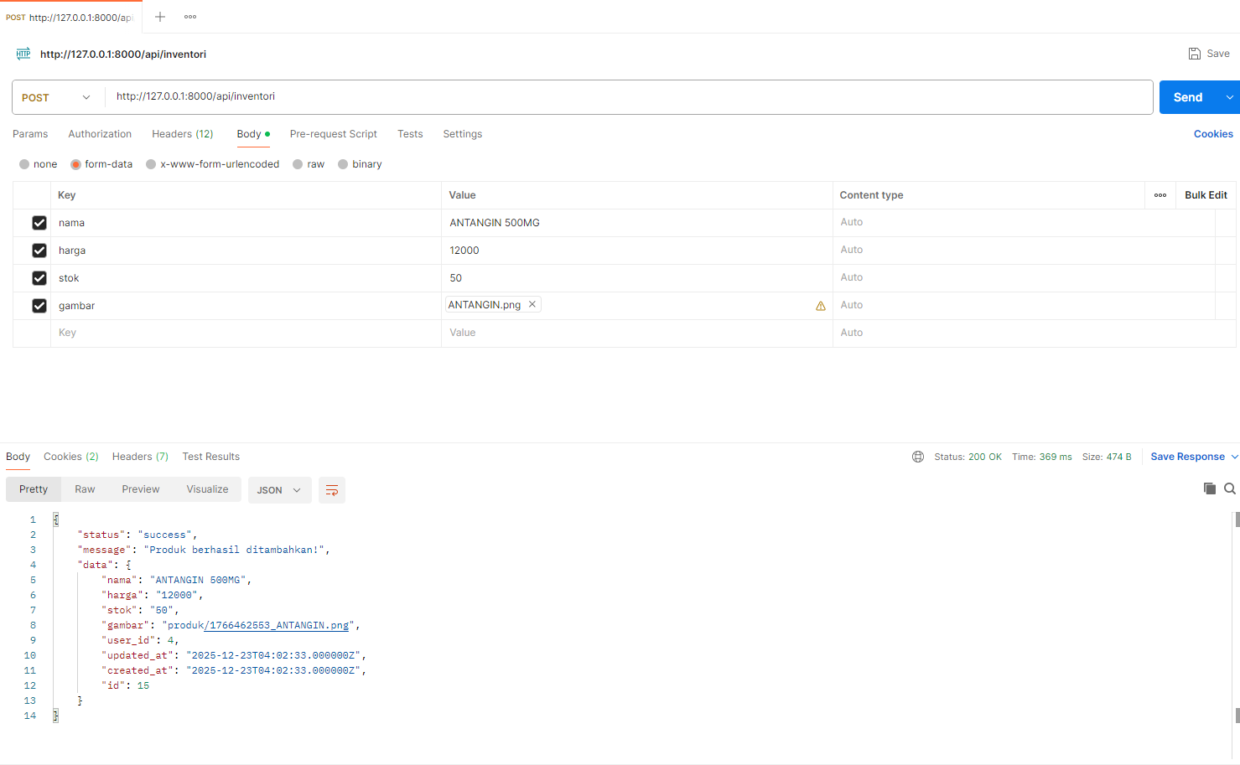

g. Update Produk

Method: PUT

URL: http://127.0.0.1:8000/api/inventori/[id]

contoh : http://127.0.0.1:8000/api/inventori/15

Headers:

Accept: application/json

Content-Type: application/json

Authorization: Bearer <token>

Body -> raw

{

"nama": "ANTANGIN 500MG",

"harga": 3000,

"stok": 100,

}

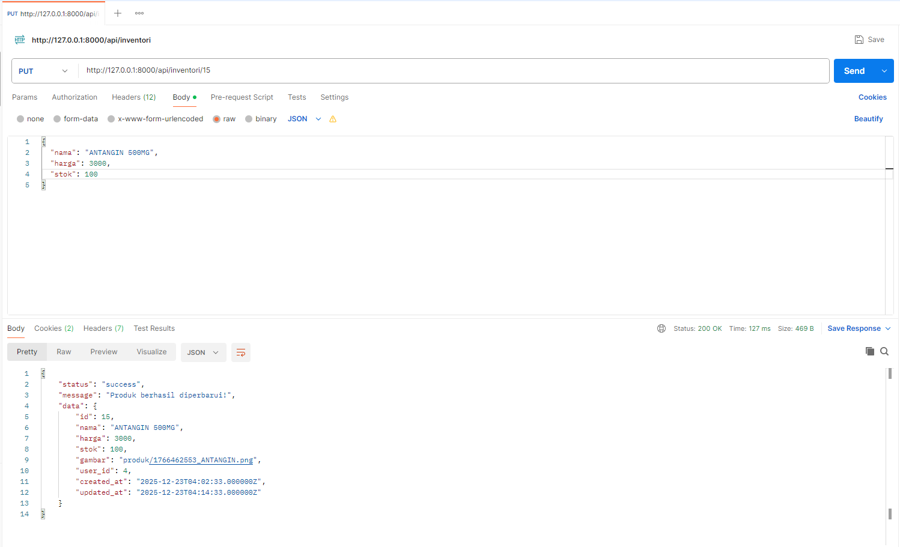

h. Hapus Produk

Method: DELETE

URL: http://127.0.0.1:8000/api/inventori/[id]

contoh : http://127.0.0.1:8000/api/inventori/15

Headers:

Accept: application/json

Authorization: Bearer <token>

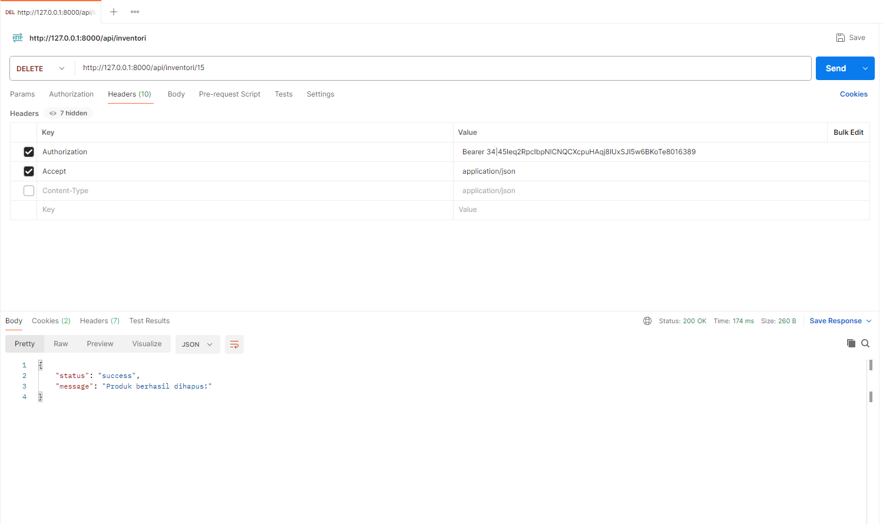

i. Logout

Method: POST

URL: http://127.0.0.1:8000/api/auth/logout

Headers:

Authorization: Bearer <token>

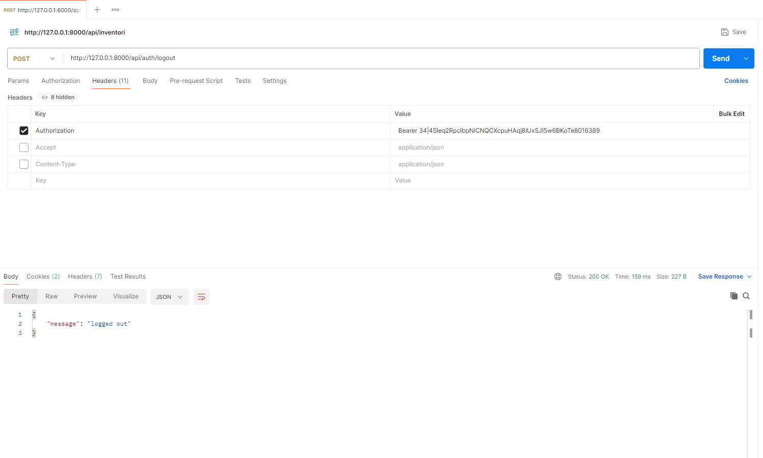

3. Tampilan React

a. Tampilan Halaman Home

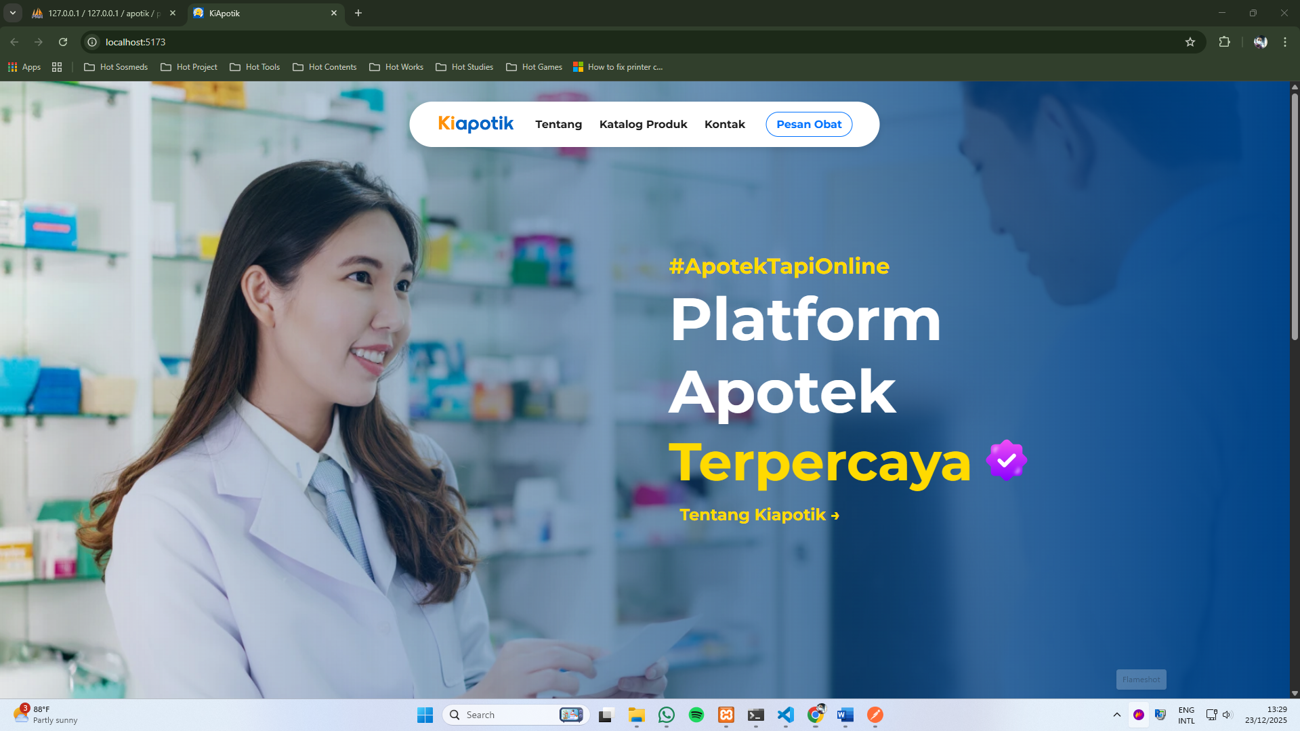

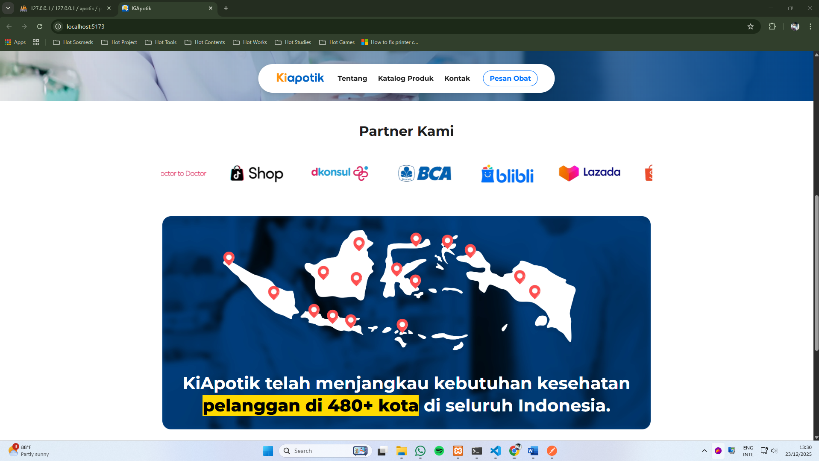

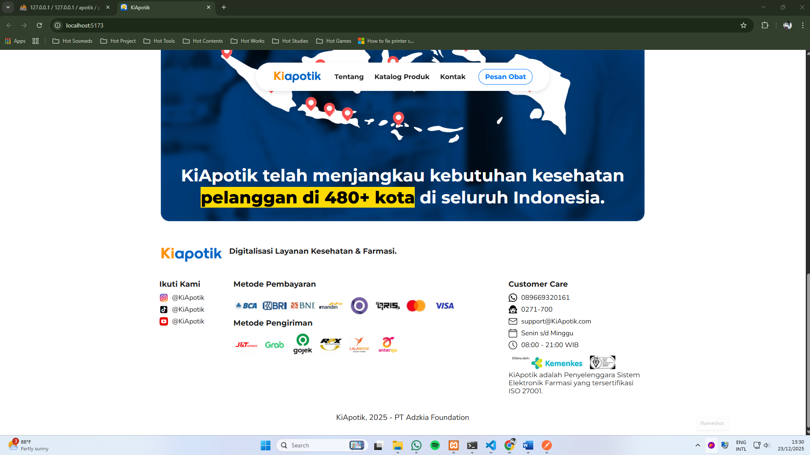

b. Tampilan Halaman Tentang

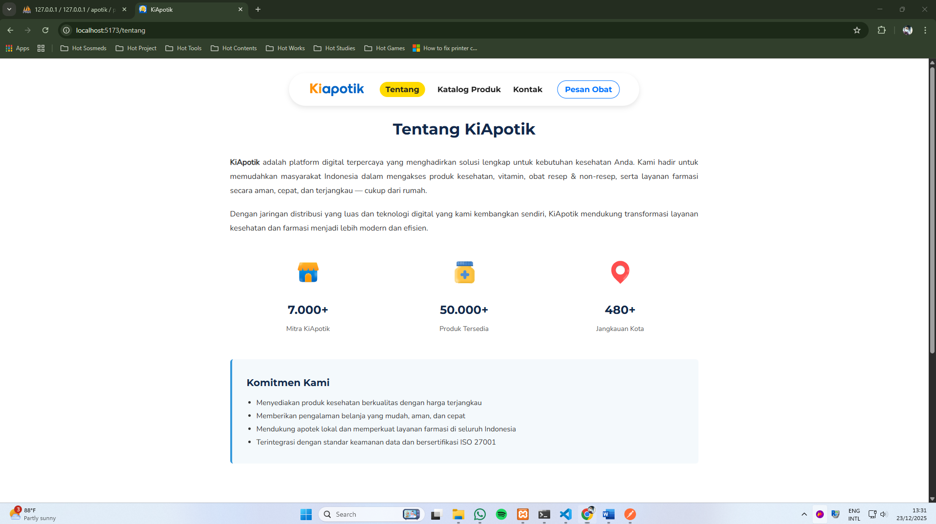

c. Tampilan Halaman Katalog

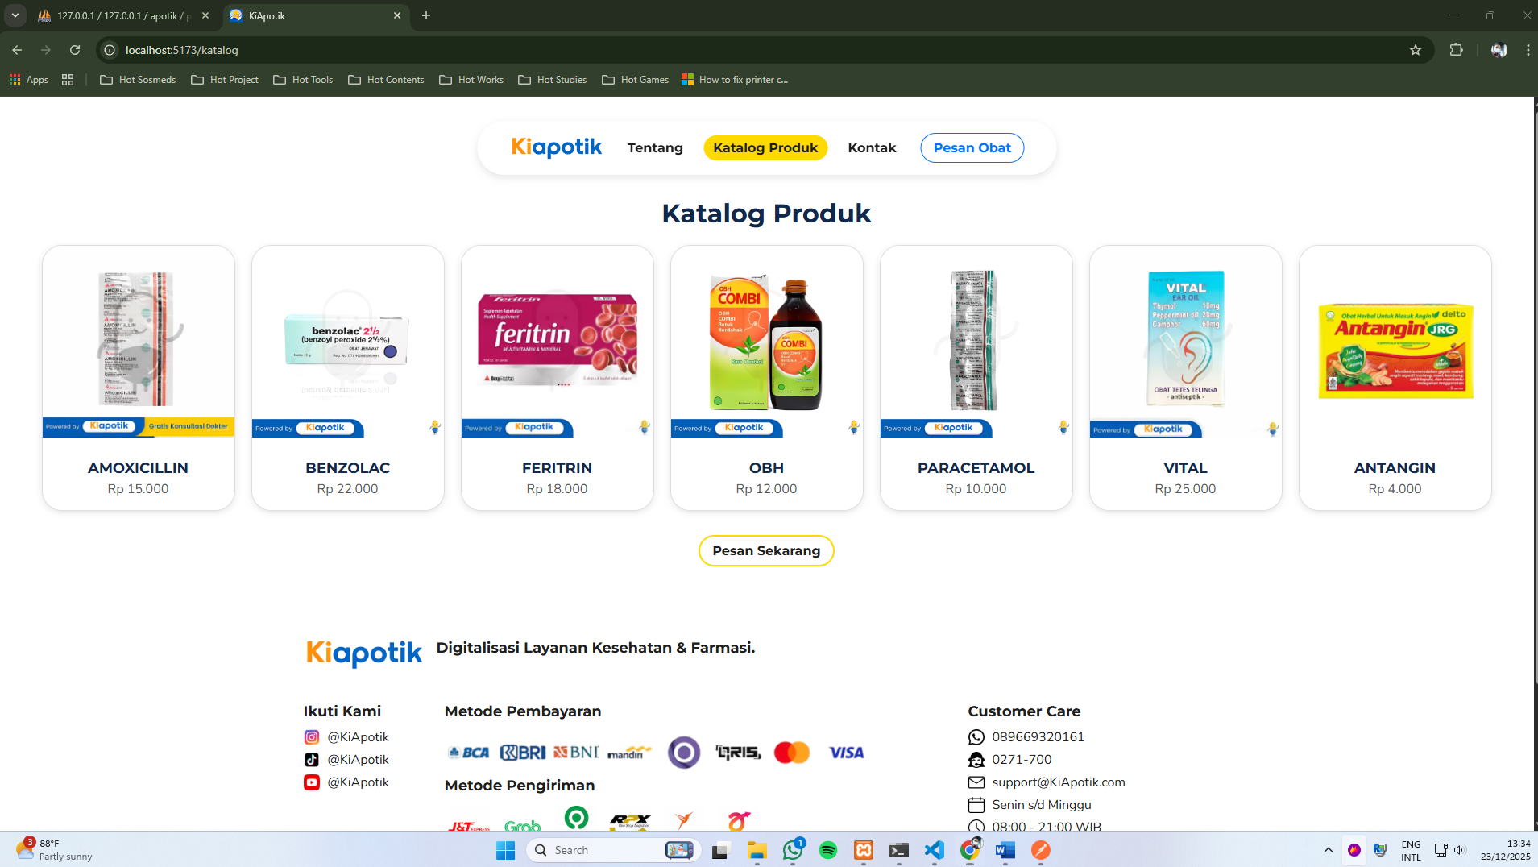

d. Tampilan Halaman Tentang

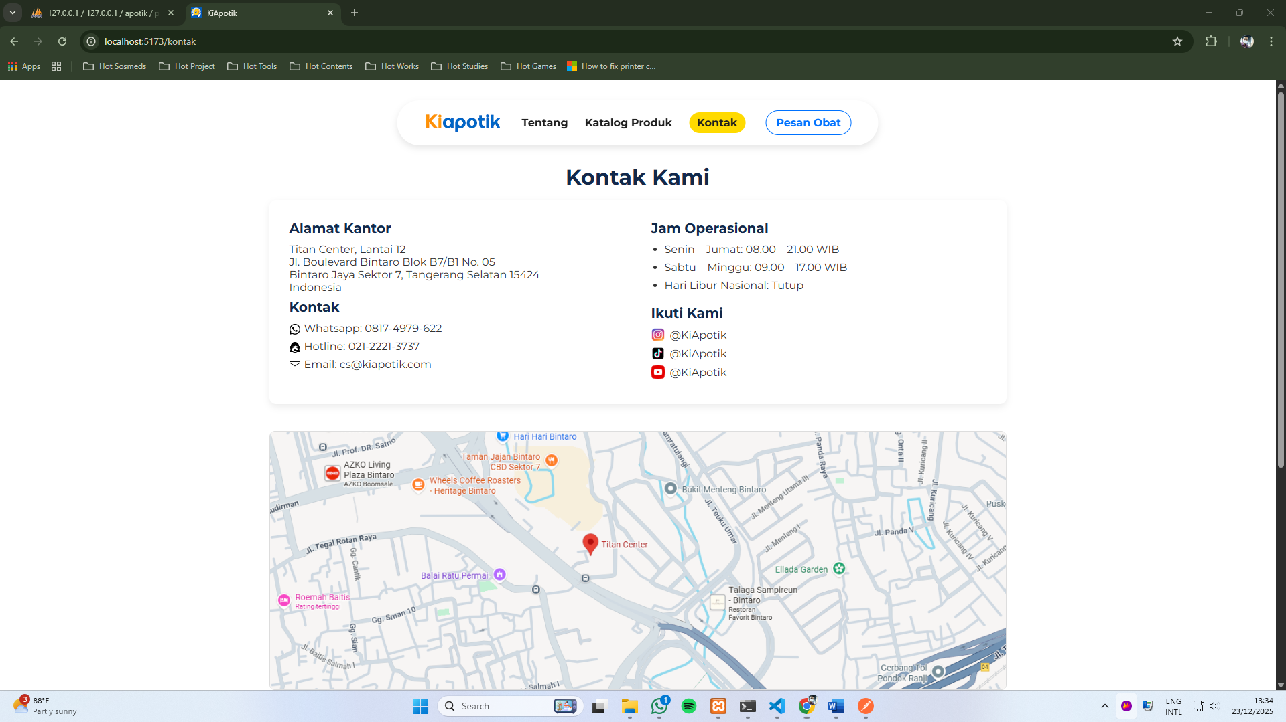

e. Tampilan Halaman Masuk

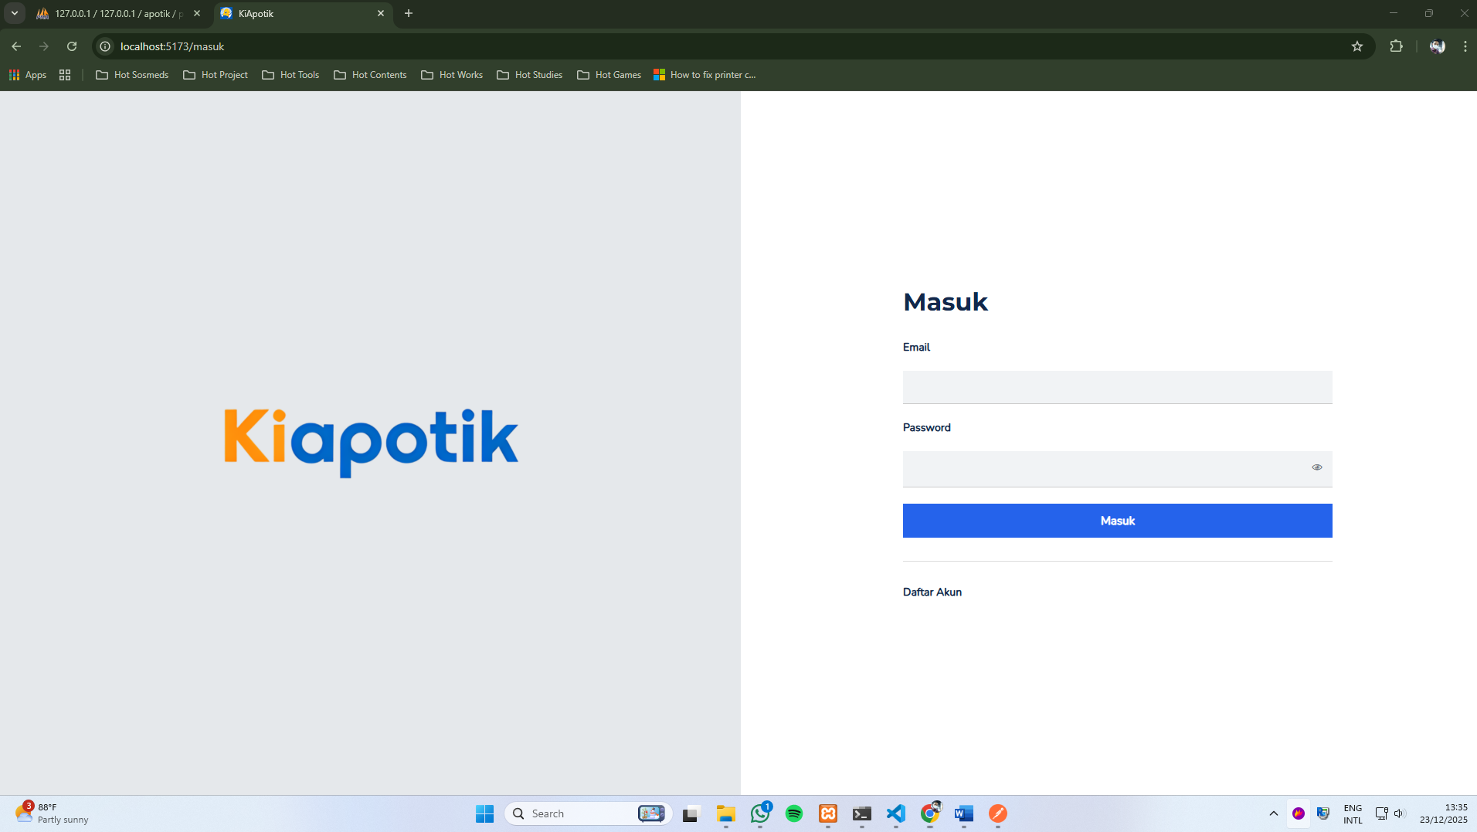

f. Tampilan Halaman Daftar

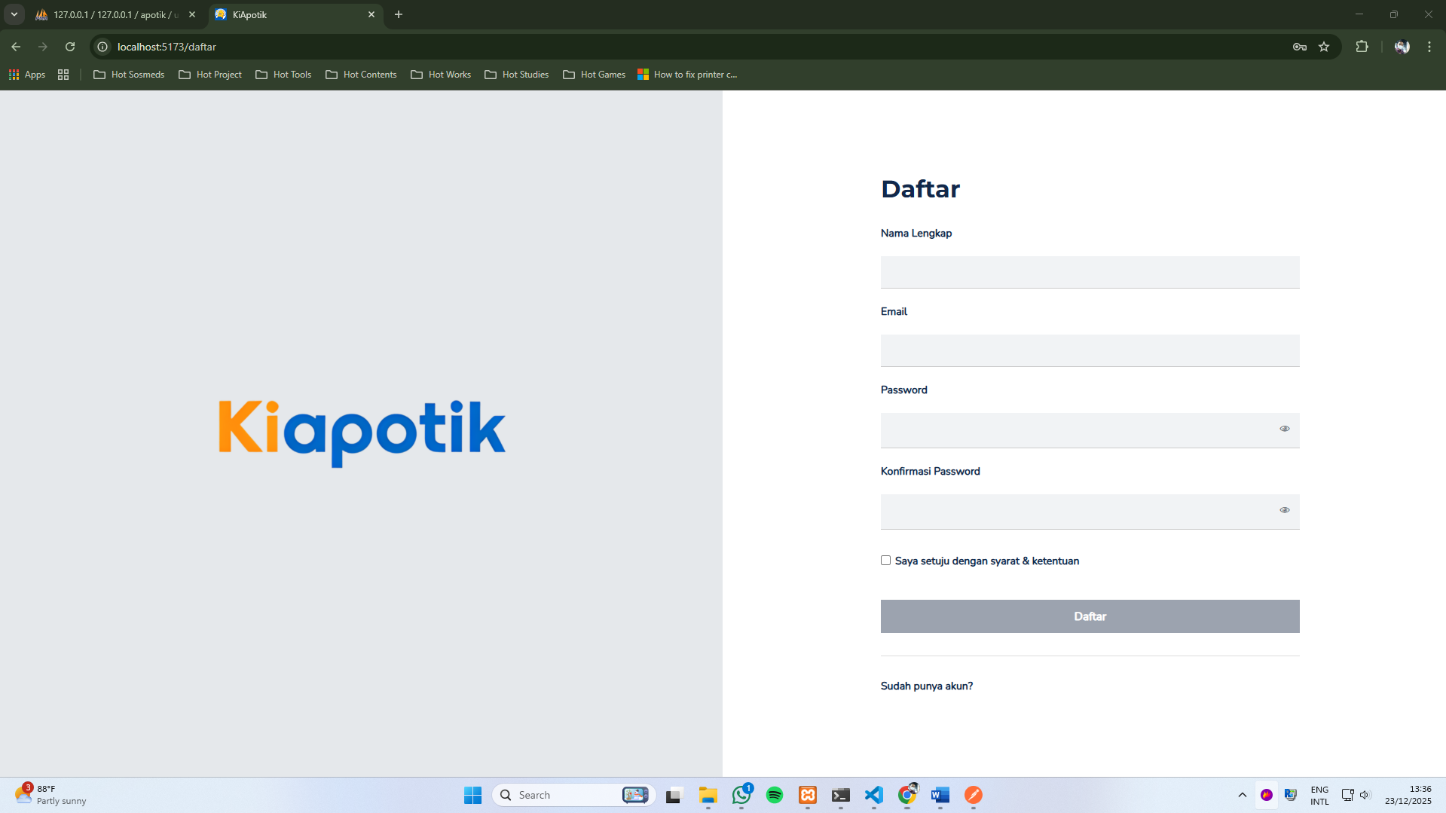

Popup Ketika sudah berhasil mendaftar

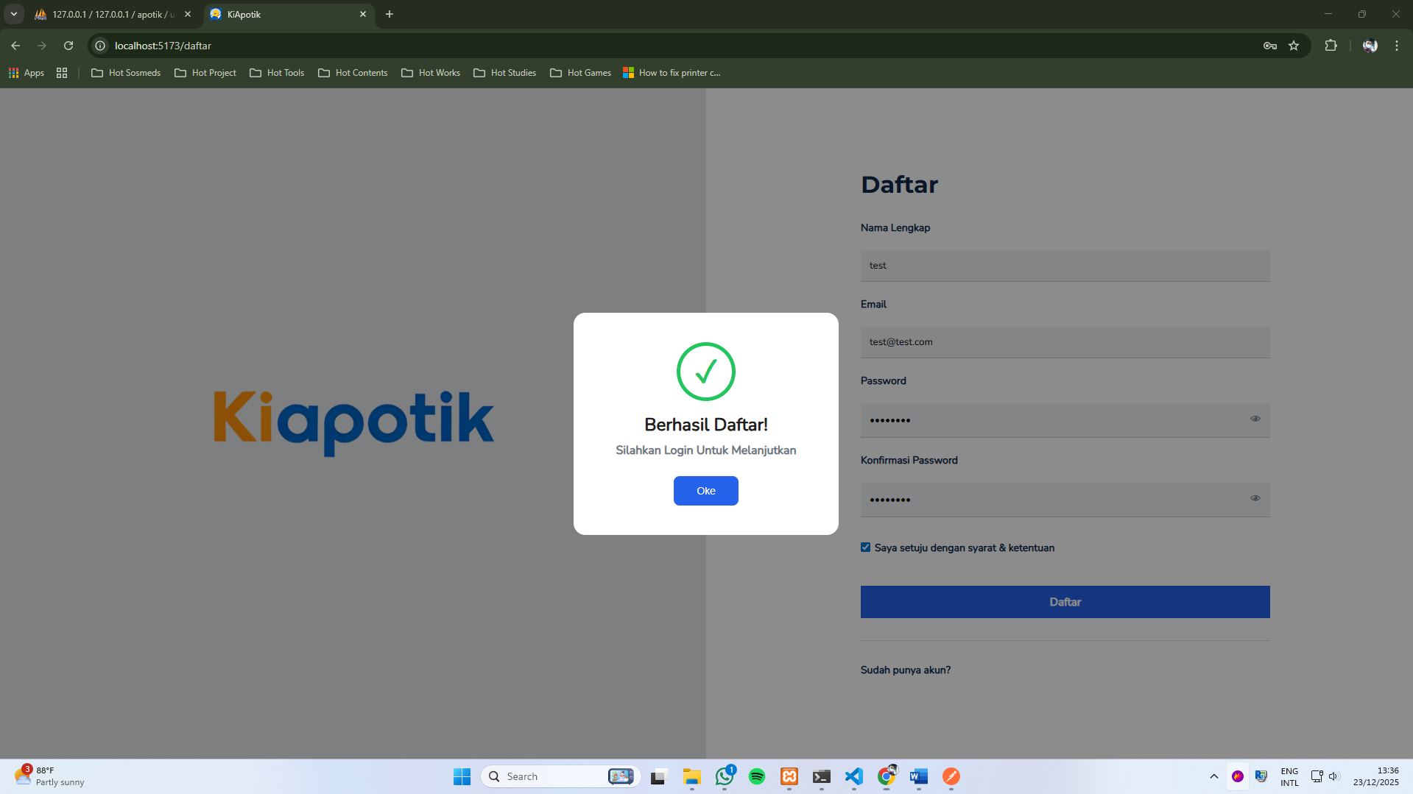

f. Tampilan Halaman Katalog Admin

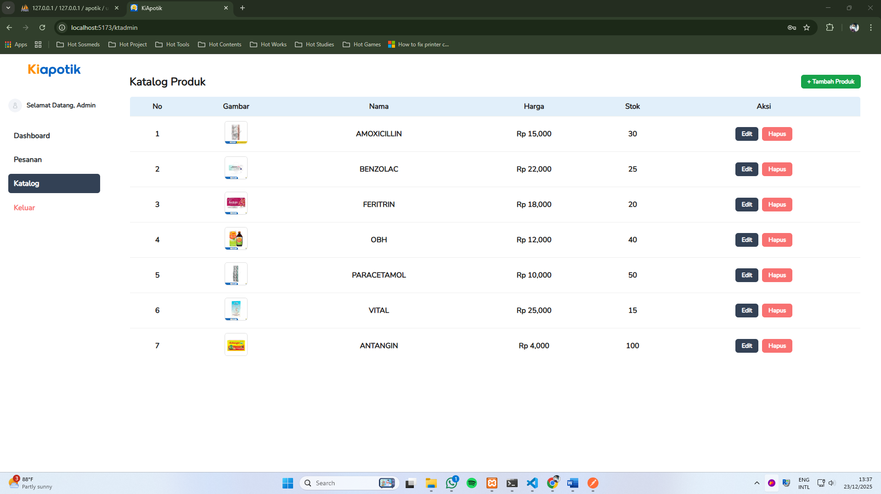

Form Tambah Produk

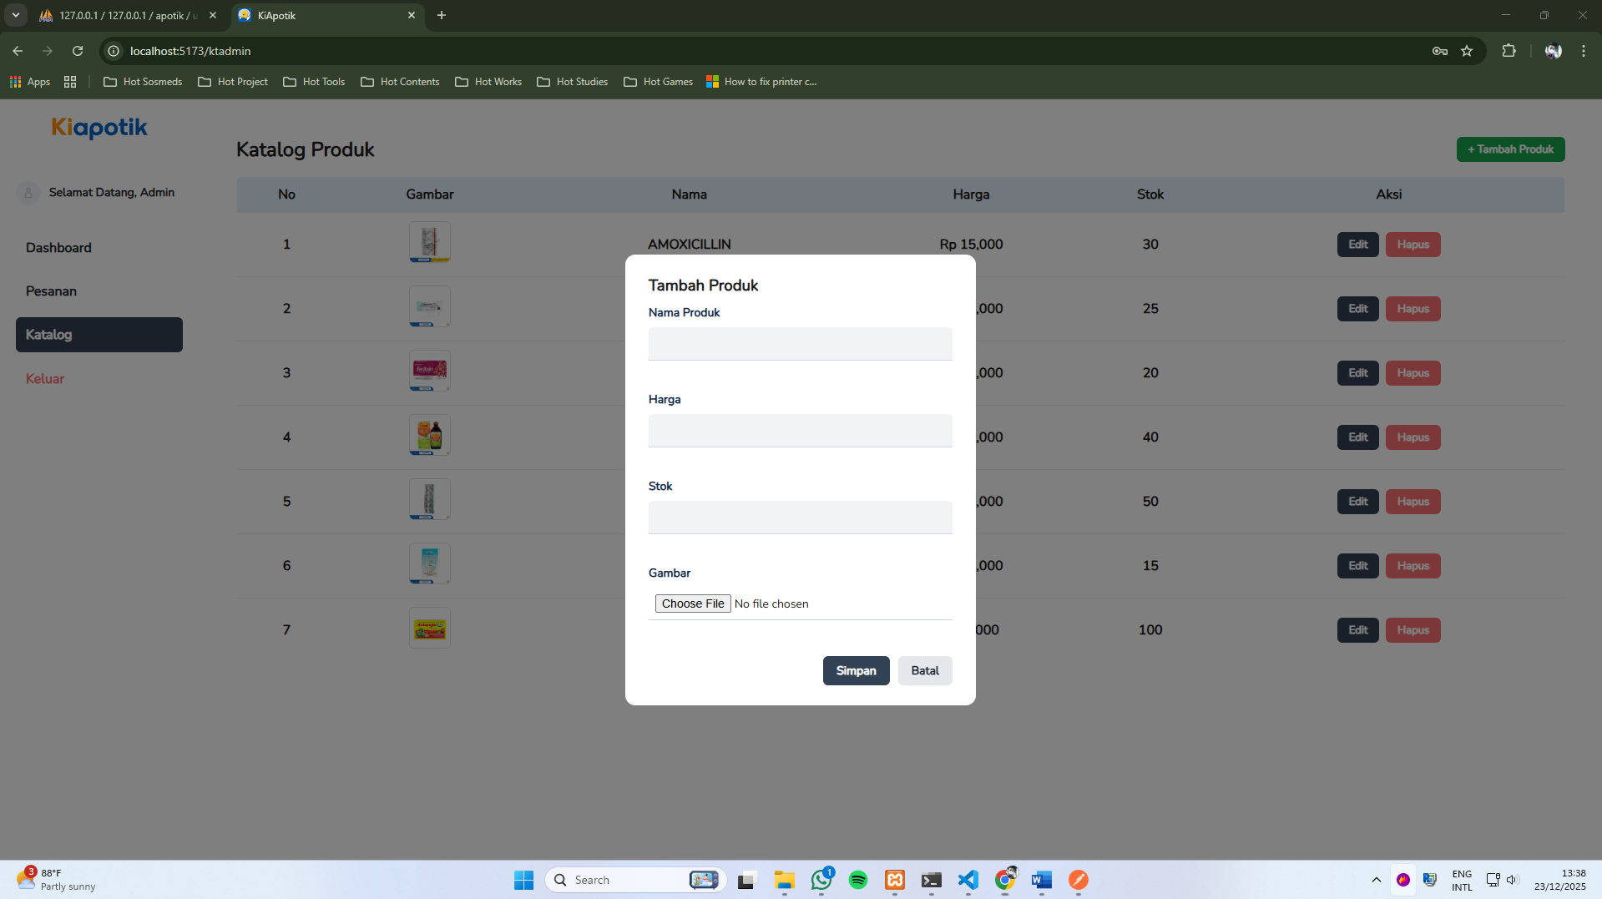

Form Edit Produk

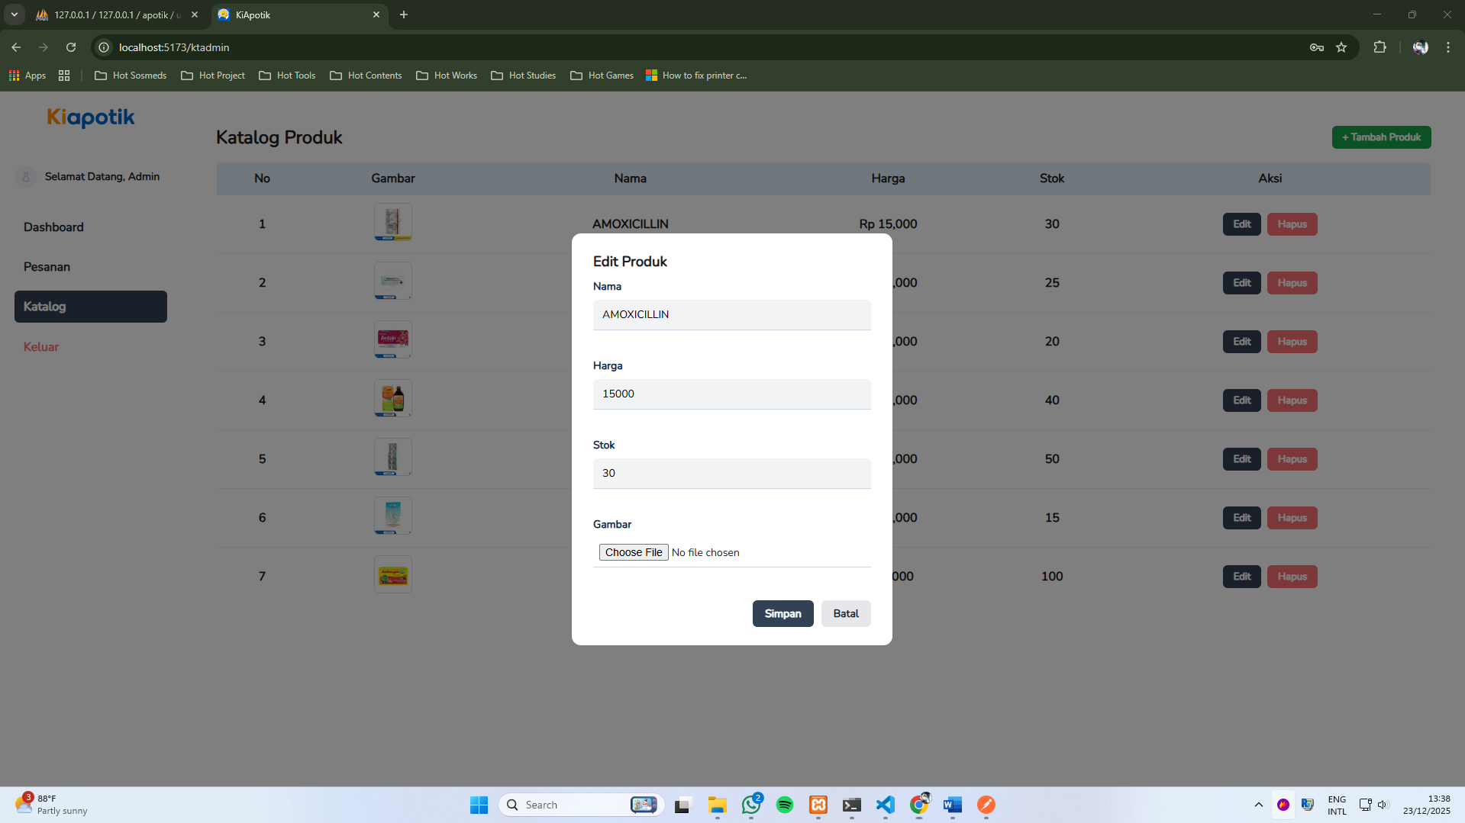

Popup Konfirmasi Ketika ingin Menghapus Produk

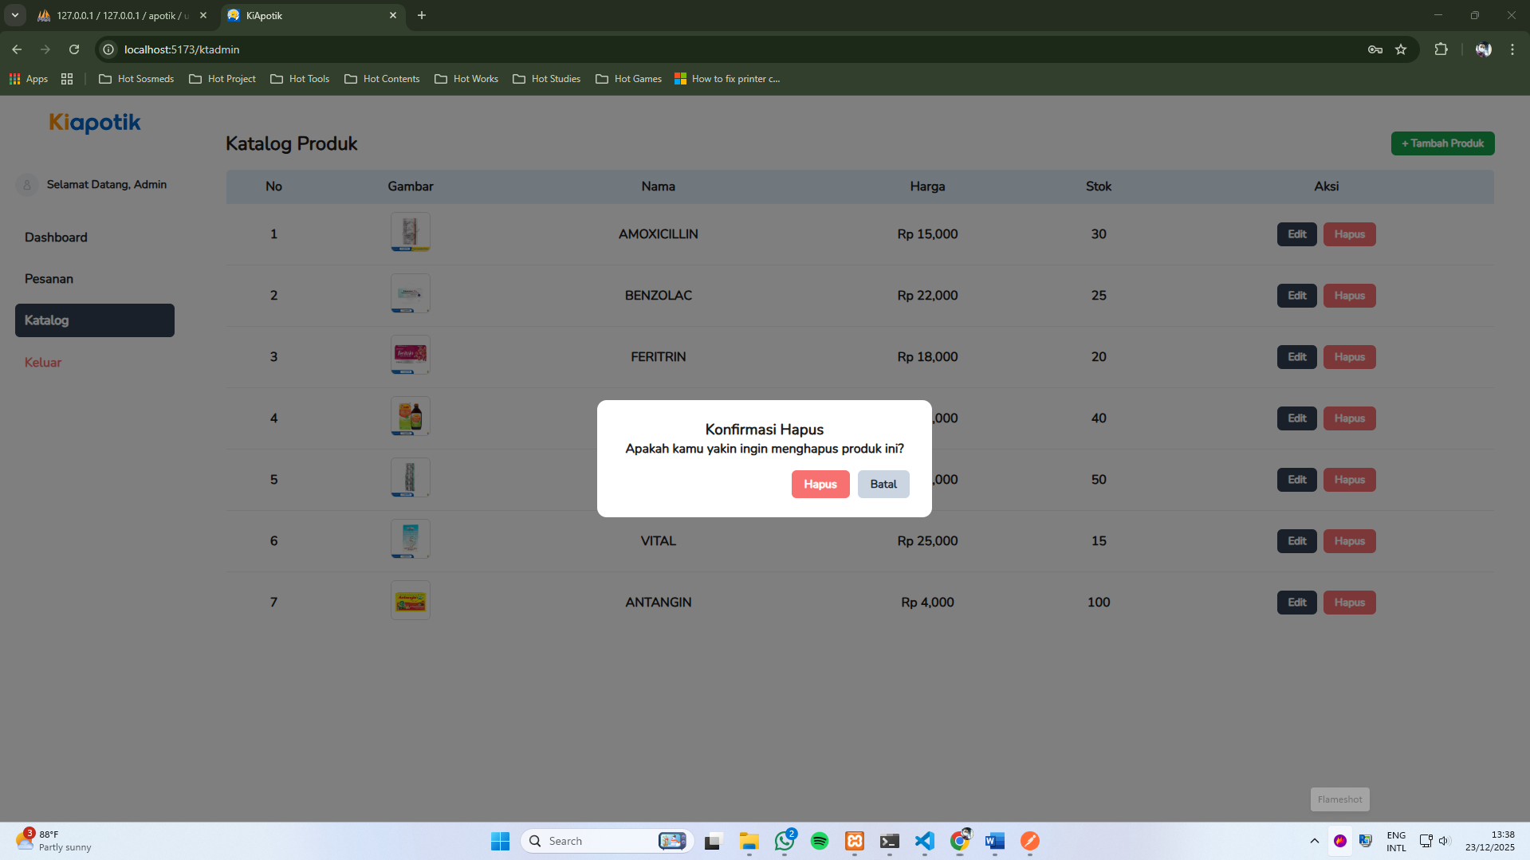

g. Tampilan Halaman Katalog User

